**Network Tiers - Optimizing Network Spend**

Overview

In this lab, you create one VM in the Premium network service tier (default) and one VM in the Standard network service tier. Then you compare the latency and network paths for each VM instance. With Network Service Tiers, Google Cloud enables you to optimize your cloud network for performance by choosing the Premium Tier or for cost with the new Standard Tier.

Premium Tier

Premium Tier delivers traffic over Google’s well-provisioned, low latency, highly reliable global network. This network consists of an extensive global private fiber network with over 100 points of presence (POPs) across the globe.

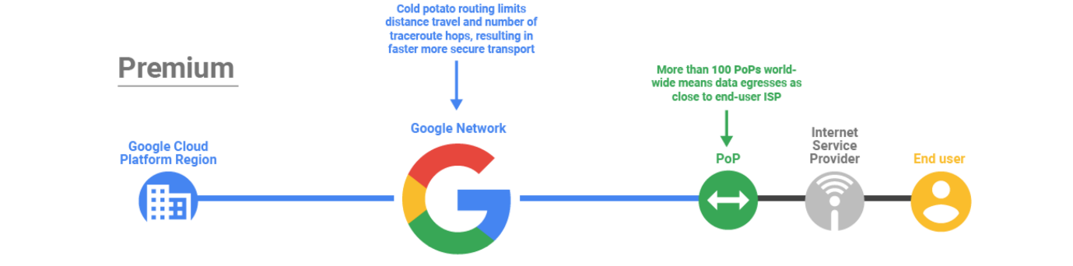

Standard Tier

Standard Tier is a new lower-cost offering. This tier provides network quality that is comparable to other public cloud providers (but lower than Premium Tier) and regional network services such as Regional Load Balancing with one VIP per region.

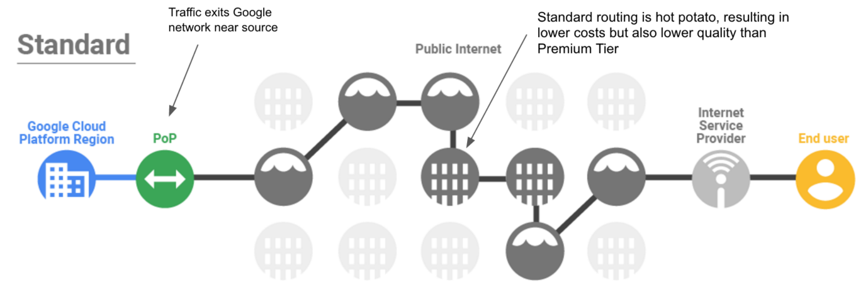

Standard tier is priced lower than Premium because your traffic between Google Cloud and your end-user (Internet) is delivered over transit (ISP) networks instead of Google’s network.

Objectives

In this lab, you learn how to perform the following tasks:

* Create a VM using the Premium network service tier
* Create a VM using the Standard network service tier
* Explore the latency and network paths for VMs on different network service tiers